Joey Galolo
Think in Boxes
https://github.com/Joey-cris/OJT-Web-Fundamentals.git
YouTube

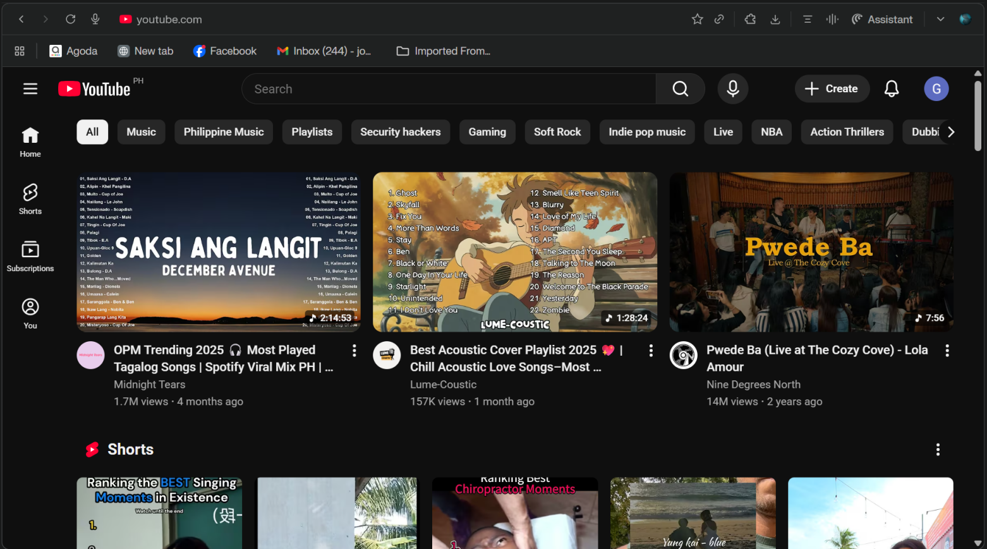

Big Blocks

Sidebar | Navigation Bar
Sidebar | Primary Recommendation
Sidebar | Content Shelf
Sidebar | Video Feed

Small Blocks
- Sidebar
Navigation Links
Hamburger Menu


- Navigation Bar

Utility Navigation
Logo
Search Bar
Keyword Pill

- Featured Section

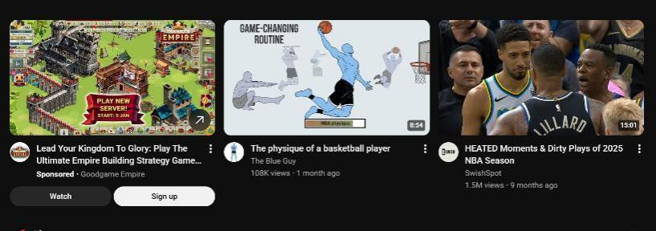
Promotion Card
Feed Cards

- Shorts Section

Vertical Video Thumbnail

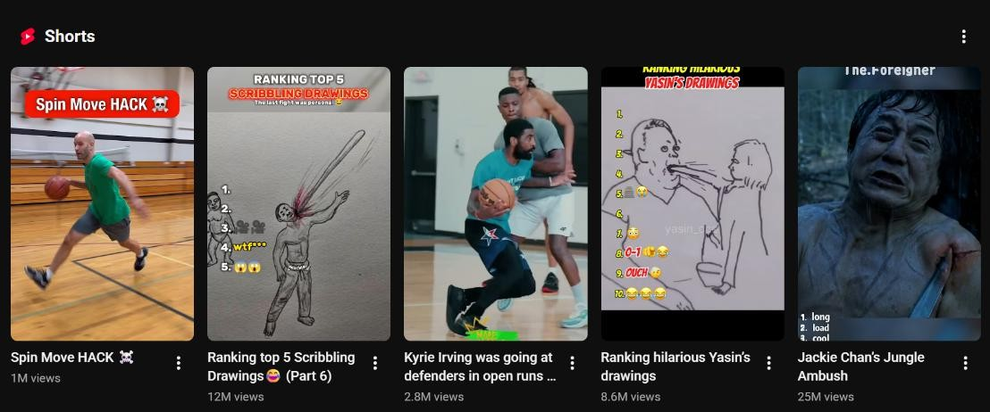
Header

- Video Feed

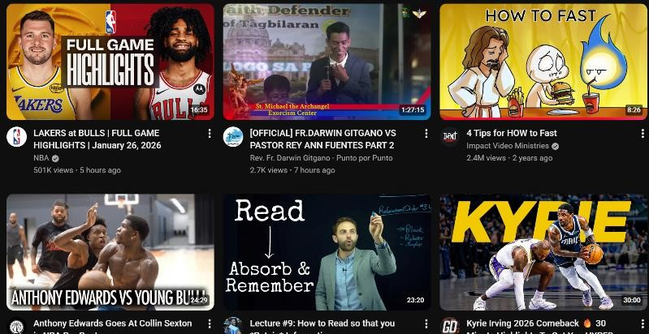
Main Content
Video card

Explanation

When analyzing YouTube’s homepage, I first identified the large blocks or major sections: the header, sidebar, main video grid, and footer. Breaking the page into these sections helped me understand the general structure without getting lost in too many details.
Next, I examined each major section and listed the smaller elements it contains. For instance, the header has the logo, search bar, and profile icon, while the main video grid consists of video thumbnails, titles, channel names, and view counts. This breakdown helped me visualize how the page is organized and how I could approach coding it using HTML and CSS.
Finally, I sketched the layout on paper, labeling each section and sub-section. This sketch serves as a blueprint for implementing the webpage design efficiently and can be used for future projects to save time and plan layouts more effectively.

